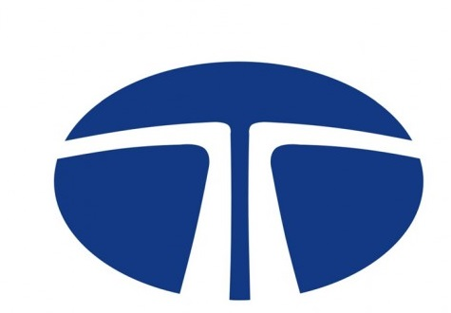



**SUBMITTED TO THE**

**Analytics & Insights DEPARTMENT**

**TATA STEEL, JAMSHEDPUR**

**Acknowledgement**

Knowledge is the one can possess. It never harms you and it is only thing that can't be lost. They are many people who simply being what they are, inspire and influence us to do things that we never thought ourselves capable of doing. I can only express my gratitude to them although this is not an adequate compensation for the time, they spend on me.

To begin with, I would like to thank to **Mr. Hari Darshan Singh and Mr. Arun Kumar Singh** and my project mentor **Mr. Satish Agarwal** for their immense support and providing with necessary information regarding the project and all the support in completing it.

I would like to thank the employees of TATA STEEL who were always there to clear my doubt.

I would also like to express my gratitude and thanks to the SNTI department for giving me the permission to do summer training at Steel, Jamshedpur.

At last I would like to thank all my team member to help and contribution in this project

**CONTENT**

**TOPICS PAGE NO PAGE NO**

**History 4**

**Company profile 5-7**

**Detect the social distance 8-22**

**Mask Detection using ImageAI 23-29**

**Detection of mask by developing 30-39**

**the model in the pre-existing dataset**

**Conclusion 40**

**Bibliography 41**

**HISTORY**

Tata Iron and Steel Company was established by [Dorabji Tata](https://en.wikipedia.org/wiki/Dorabji_Tata) on 26 August 1907, as part of his father [Jamsetji](https://en.wikipedia.org/wiki/Jamsetji_Tata)'s [Tata Group](https://en.wikipedia.org/wiki/Tata_Group).By 1939 it operated the largest steel plant in the British Empire. The company launched a major modernization and expansion program in 1951. Later in 1958, the program was upgraded to 2 Million metric tons per annum (MTPA) project. By 1970, the company employed around 40,000 people at Jamshedpur, with a further 20,000 in the neighboring coal mines. In 1971 and 1979, there were unsuccessful attempts to nationalize the company. In 1990, it started expansion plan and established its subsidiary Tata Inc. in New York. The company changed its name from TISCO to Tata Steel in 2005. Tata Steel on Thursday(12 Feb 2015) announced buying three strip product services centers in Sweden, Finland and Norway from SSAB to strengthen its offering in Nordic region. The company, however, did not disclose value of the transactions.

In August 2004, Tata Steel agreed to acquire the steel making operations of the Singapore-based NatSteel for $486.4 million in cash. NatSteel had ended 2003 with turnover of $1.4 billion and a profit before tax of $47 million.

Tata Steel acquired a majority stake in the Thailand-based steelmaker Millennium Steel for a total cost of $130 million. It paid US$73 million to Siam Cement for a 40% stake and offered to pay 1.13 baht per share for another 25% of the shares of other shareholders.

**COMPANY PROFILE**

**Tata Steel Limited** (formerly Tata Iron and Steel Company Limited (TISCO)) is an Indian multinational [steel](https://en.wikipedia.org/wiki/Steel)-making company headquartered in [Mumbai, Maharashtra](https://en.wikipedia.org/wiki/Mumbai,_Maharashtra), India, and a subsidiary of the [Tata Group](https://en.wikipedia.org/wiki/Tata_Group). It was the [11th largest steel producing company in the world](https://en.wikipedia.org/wiki/List_of_steel_producers) in 2013, with an annual [crude steel](https://en.wikipedia.org/wiki/Crude_steel) capacity of 25.3 million tons, and the second largest private-sector steel company in India (measured by domestic production) with an annual capacity of 9.7 million tons after [SAIL](https://en.wikipedia.org/wiki/Steel_Authority_of_India).

Tata Steel has manufacturing operations in 26 countries, including Australia, China, India, the Netherlands, Singapore, Thailand and the United Kingdom, and employs around 80,500 people. Its largest plant is located in [Jamshedpur](https://en.wikipedia.org/wiki/Jamshedpur), [Jharkhand](https://en.wikipedia.org/wiki/Jharkhand). In 2007 Tata Steel acquired the UK-based steel maker Corus which was the largest international acquisition by an Indian company till that date. It was ranked 486th in the 2014 [Fortune Global 500](https://en.wikipedia.org/wiki/Fortune_Global_500) ranking of the world's biggest corporations. It was the seventh most valuable Indian brand of 2013 as per [Brand Finance](https://en.wikipedia.org/wiki/Brand_Finance).

On 16 February 2012 Tata Steel completed 100 years of steel making in India.

Tata Steel is headquartered in Mumbai, Maharashtra, India and has its marketing headquarters at the [Tata Centre](https://en.wikipedia.org/wiki/Tata_Centre) in [Kolkata, West Bengal](https://en.wikipedia.org/wiki/Kolkata,_West_Bengal). It has a presence in around 50 countries with manufacturing operations in 26 countries including: India, Malaysia, Vietnam, Thailand, UAE, Ivory Coast, Mozambique, South Africa, Australia, United Kingdom, The Netherlands, France and Canada.

Tata Steel primarily serves customers in the automotive, construction, consumer goods, engineering, packaging, lifting and excavating, energy and power, aerospace, shipbuilding, rail and defence and security sectors.

**AWARDS AND RECOGNITIONS**

* Tata Steel was awarded the '2015 World's Most Ethical Company' award under the Metals category by the [Ethisphere Institute](https://en.wikipedia.org/wiki/Ethisphere_Institute). This was the third time that Tata Steel won this award.
* The Ministry of Steel awarded Tata Steel the Prime Minister's Trophy for 'Best Performing Integrated Steel Plant' in the year 2010-11, thus making it the eighth time that Tata Steel received this award since the trophy's institution in 1992-93.
* In 2014, Tata Steel received the *‘*Top Indian Company in the Iron and Steel Sector’ Dun & Bradstreet Corporate Award 2014, after entering the list of India's Top 500 Companies published by [Dun & Bradstreet](https://en.wikipedia.org/wiki/Dun_%26_Bradstreet) and excelling along various business and social parameters.
* In the year 2013, Tata Steel was ranked India's 7th most admired company by [Fortune magazine](https://en.wikipedia.org/wiki/Fortune_(magazine)). It was India's most admired company in 2012.
* In 2013, Tata Steel received the [Most Admired Knowledge Enterprises](https://en.wikipedia.org/w/index.php?title=Most_Admired_Knowledge_Enterprises&action=edit&redlink=1) (MAKE) award for 2012 at Global and Asian level. The company has previously been recognized by the Indian MAKE awards on six accounts since its inception in 2005.
* It won the 'Golden Peacock' award in 2009 for its corporate social responsibility (CSR) initiatives.
* In 1996, the Tata Bearings division was awarded the "Best of all" [Rajiv Gandhi National Quality Award](https://en.wikipedia.org/wiki/Rajiv_Gandhi_National_Quality_Award)
* In 2008, Tata Steel was awarded [Deming Application Prize](https://en.wikipedia.org/wiki/Deming_Prize) for excellence in Total Quality Management.
* In 2012, Tata Steel became the first integrated steel company in the world to be awarded the [Deming Grand Prize](https://en.wikipedia.org/wiki/Deming_Prize).
* The company features in the Climate Disclosure Leadership Index of CDP (see [Carbon Disclosure Project](https://en.wikipedia.org/wiki/Carbon_Disclosure_Project)). Its disclosure received 97% CDLI score in CDP 2014 (85% in CDP 2013) that is rated highest amongst global Steelmaking companies and highest amongst Materials sector in India.
* Tata Steel was ranked 110th among India's most trusted brands according to the [Brand Trust Report](https://en.wikipedia.org/wiki/The_Brand_Trust_Report) 2012, a study conducted by Trust Research Advisory. In the [Brand Trust Report](https://en.wikipedia.org/wiki/The_Brand_Trust_Report) 2013, Tata Steel was ranked 364th among India's most trusted brands while according to the Brand 2014, Tata Steel was ranked 264th among India's most trusted brands. It was among 16 of [Tata Group](https://en.wikipedia.org/wiki/Tata_Group)'s subsidiary brands to feature in the report apart from the parent brand. [Ratan Tata](https://en.wikipedia.org/wiki/Ratan_Tata) also featured in the report among India's most trusted 'Personality' brands.

**Detect the social distance**

**1.1 Introduction**

Coronavirus disease 2019 (COVID-19) is an infectious disease caused by severe acute respiratory syndrome coronavirus 2 (SARS-CoV-2). It was first identified in December 2019 in Wuhan, the capital of China's Hubei province, and has since spread globally, resulting in an ongoing pandemic. As of 7 May 2020, more than 3.78 million cases have been reported across 187 countries and territories, resulting in more than 264,000 deaths. More than 1.25 million people have recovered.

The virus is primarily spread between people during close contact, often via small droplets produced by coughing, sneezing, and talking. The droplets usually fall to the ground or onto surfaces rather than remaining in the air over long distances.

People may also become infected by touching a contaminated surface and then touching their face. Recommended measures to prevent infection include frequent hand washing, maintaining physical distance from others face covering use by the general public vary, with some authorities recommending, some recommending against, and others requiring their use

**1.2 TOOL’S USED**

"PREVENTION IS BETTER THAN CURE" as world grow technology become more powerful, when whole world is undergoing through this situation, technology play vital role to solve the problem.

1.Visualization:

I have used Tableau Desktop to visualize the region affected by covid-19

Visualization 1: Status of Covid 19

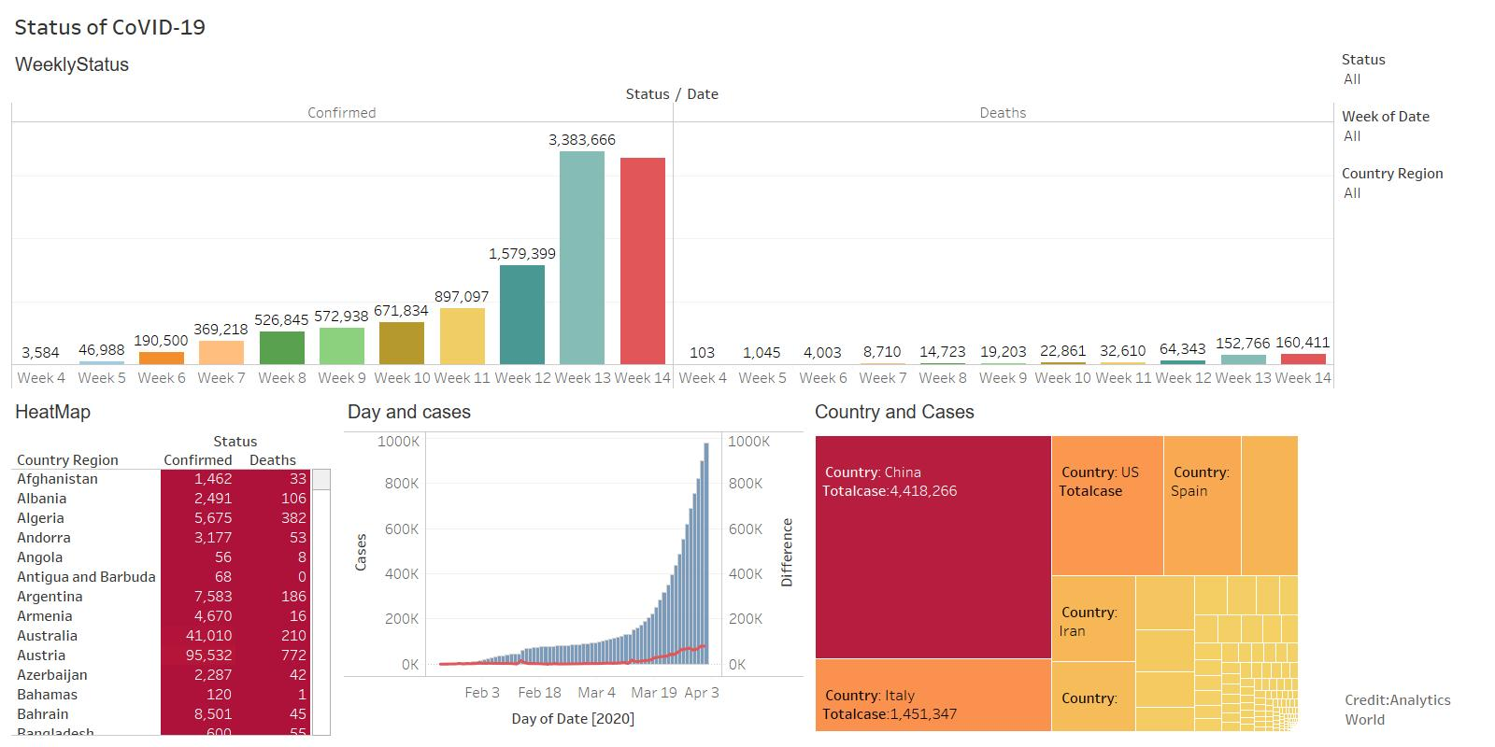

If you want to show the variation of the above visualization, please visit the link given

<https://public.tableau.com/profile/gaurav.kumar7925#!/vizhome/StatusofCovid-19/Dashboard1>

Visualization 2: Status of Covid all over the world

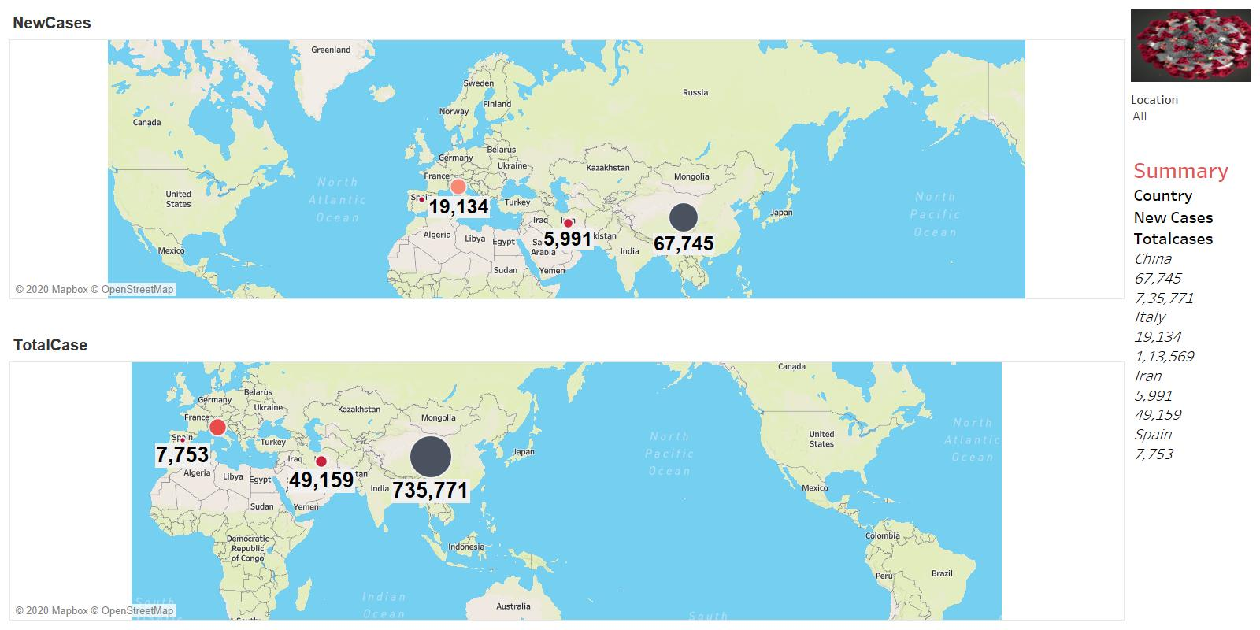

If you want to show the variation of the above visualization, please visit the link given

<https://public.tableau.com/profile/gaurav.kumar7925#!/vizhome/NewCasesandTotalCasesCoVidMapview/Dashboard3>

2.JupyterNoteBook

Project Jupyter exists to develop open-source software, open-standards, and services for interactive computing across dozens of programming languages.

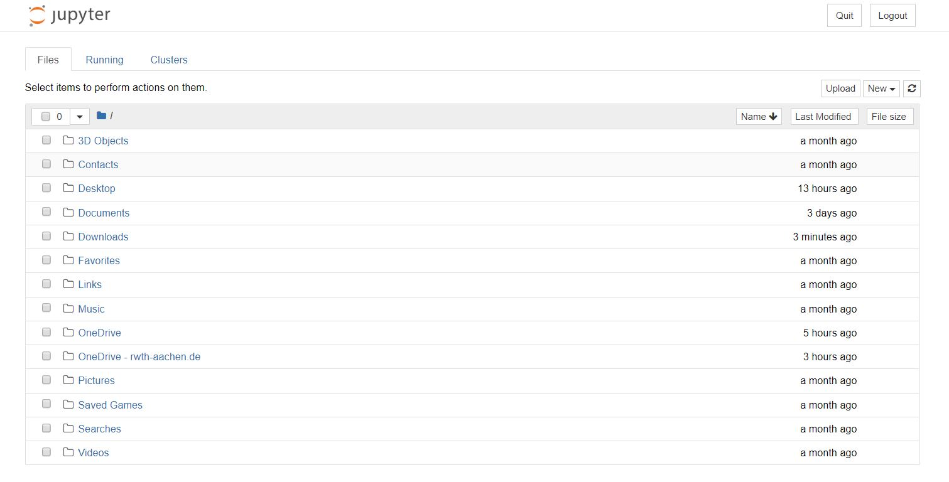

**1.3 Monitor Social Distancing in a Public Area**

Social distancing is an important way to slow down the spread of infectious diseases.

People are asked to limit their interactions with each other, reducing the chances of the disease being spread with physical or close contact.

we have used python combined with deep learning and computer vision to monitor social distancing.

**1.4 Implementation of the process**

**STEP 1: Install required packages**

First, I have installed the required packages

* absl-py
* Astor
* bleach
* certify
* enum34
* gast
* google-pasta
* grpcio
* h5py
* html5lib
* Keras-Applications
* Keras-Preprocessing
* Markdown
* numpy
* OpenCV-python
* protobuf
* SciPy
* six
* tensor board
* TensorFlow
* TensorFlow-estimator
* tensorflow-tensorboard
* term color
* Werkzeug
* Wrapt

We must run following command in anaconda prompt to install all these packages using the following command

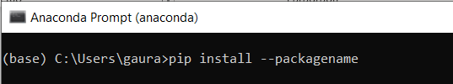

**STEP: 2 Python Code**

Importing the library

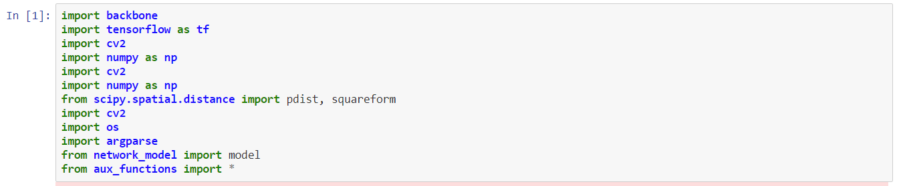

**NETWORK**

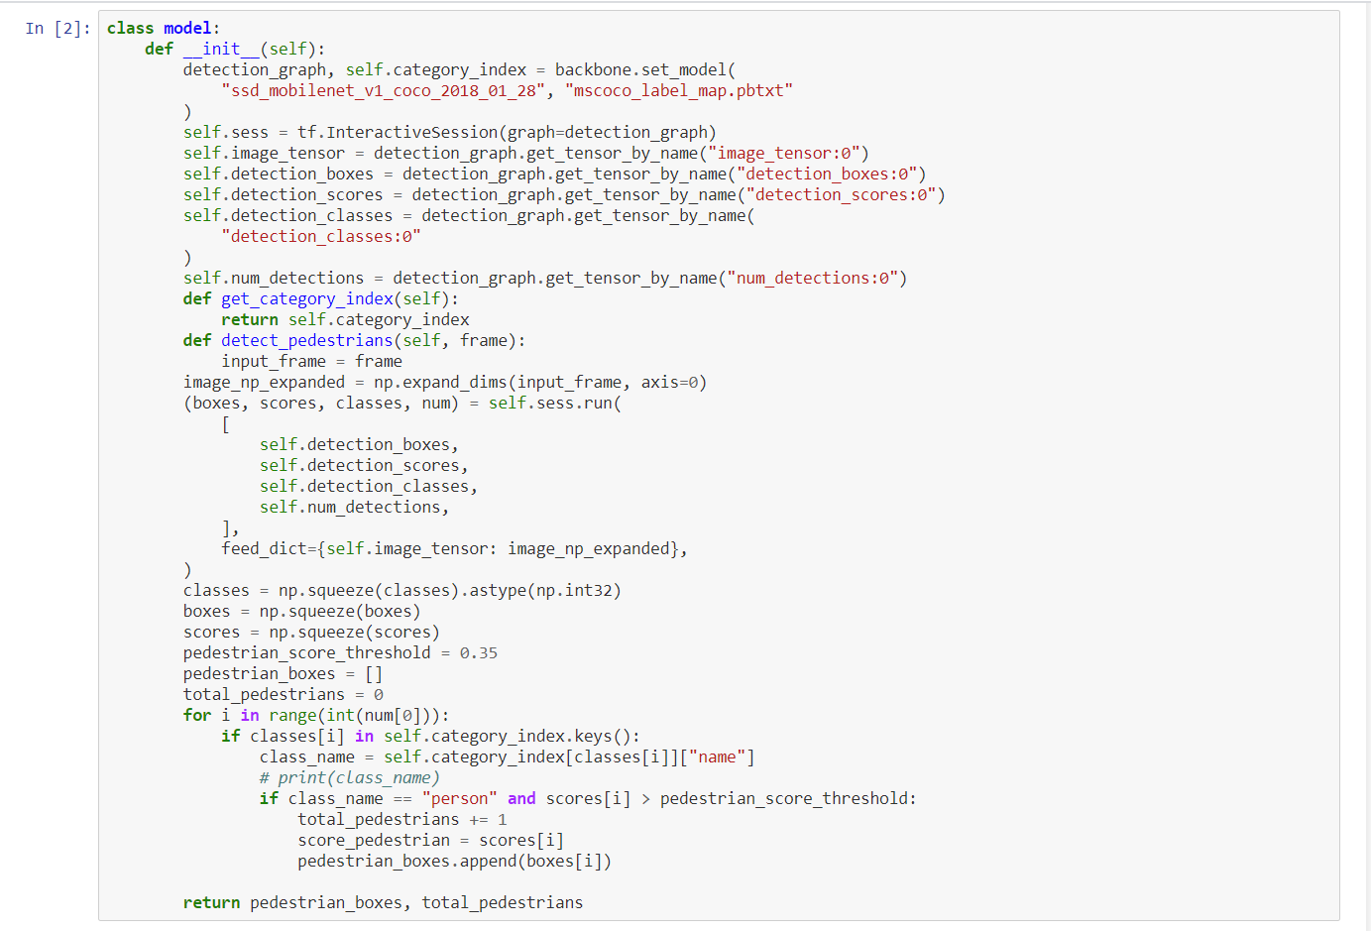

**Define the Function**

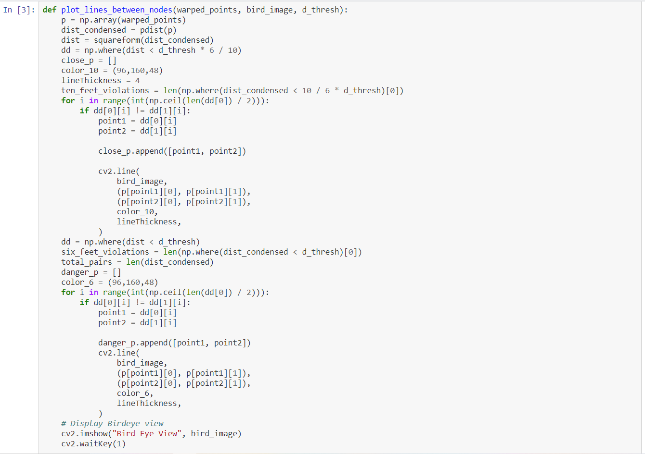

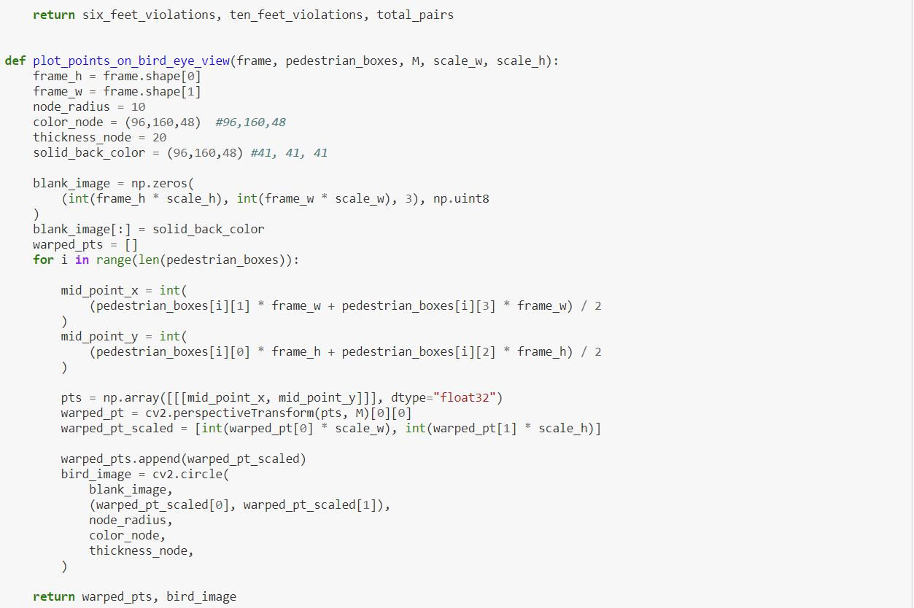

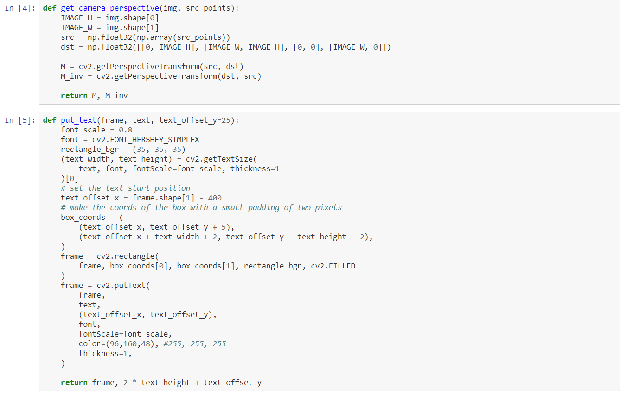

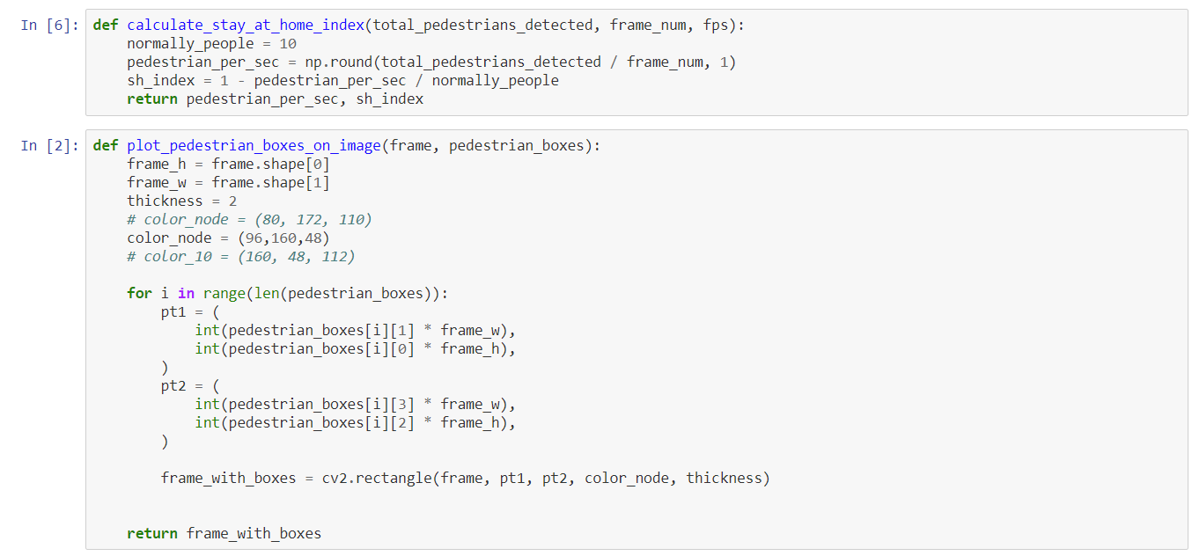

For access the .ipynb file please find the attachment



**Main Function :**

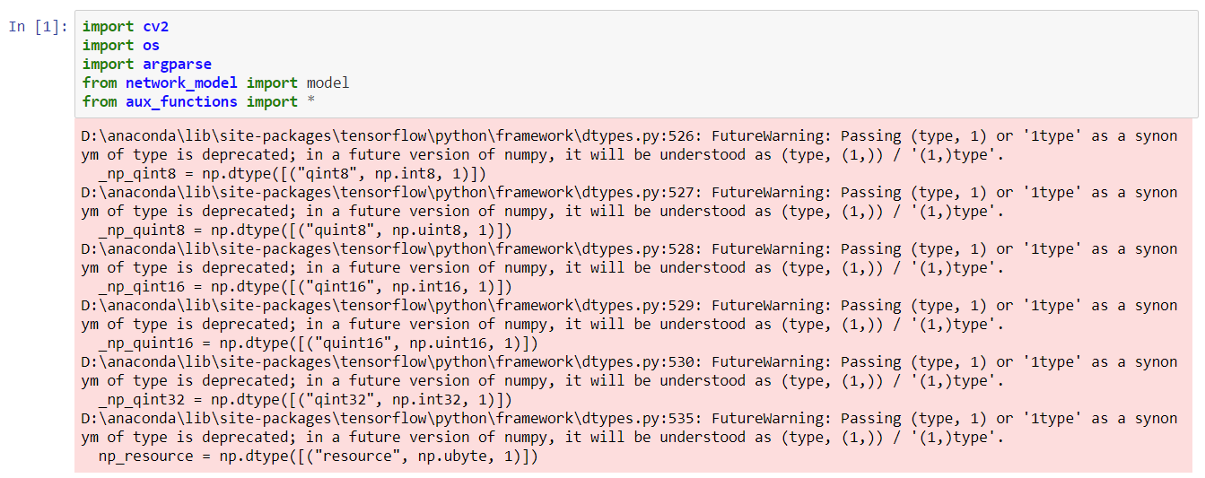

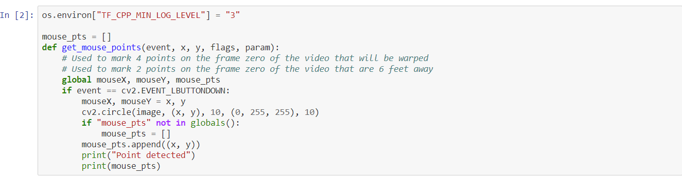

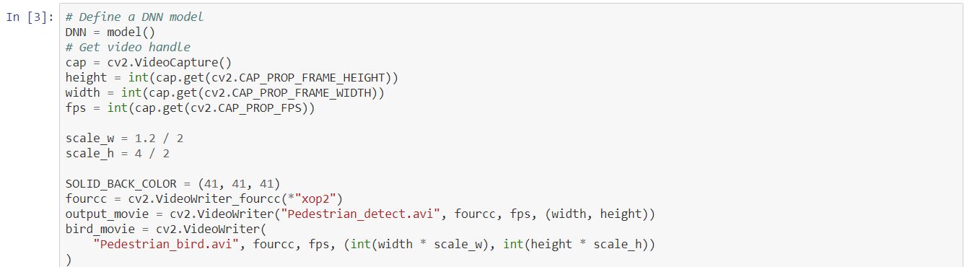

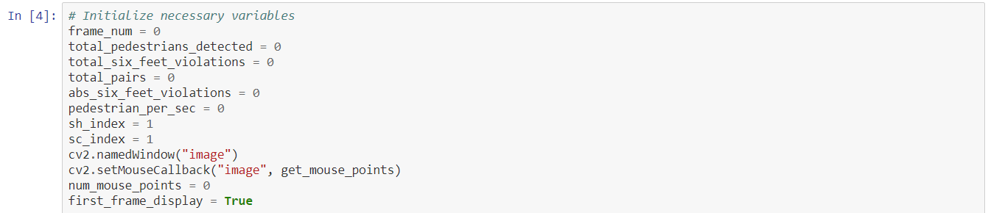

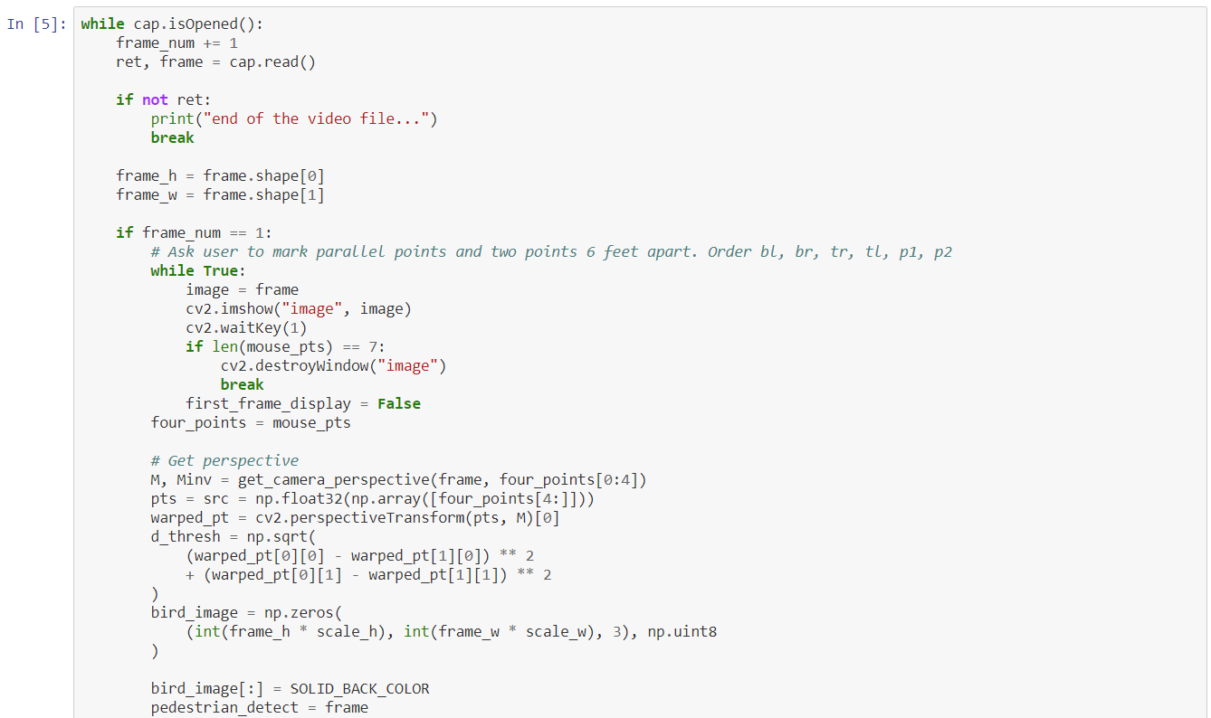

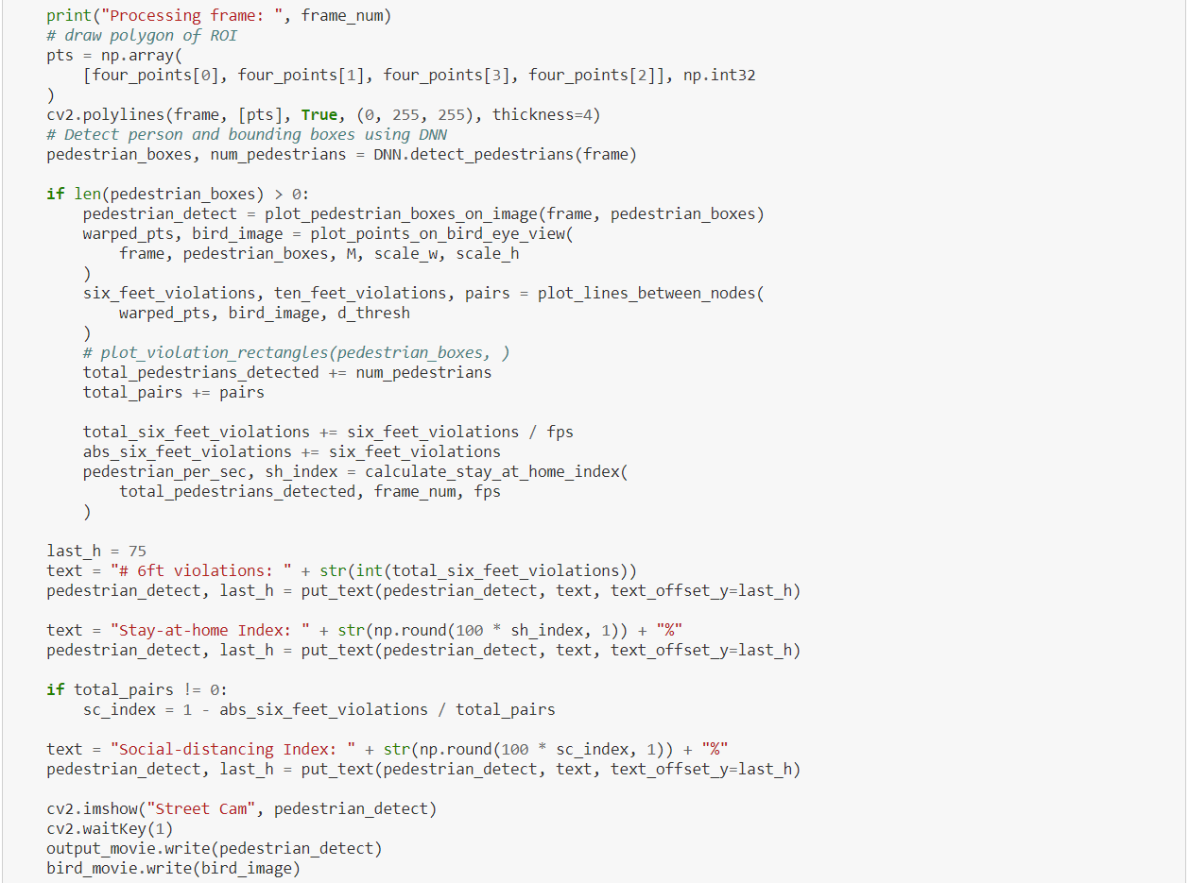

Please attached the file for main function



**STEP 3 : OUTPUT**

Once the code is executed , we must go to anaconda prompt and then access the file where this code is placed

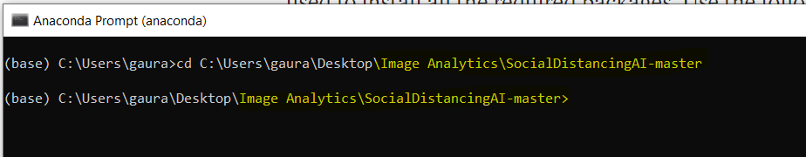

Once we will in the respective folder, we must run the following command to execute main function

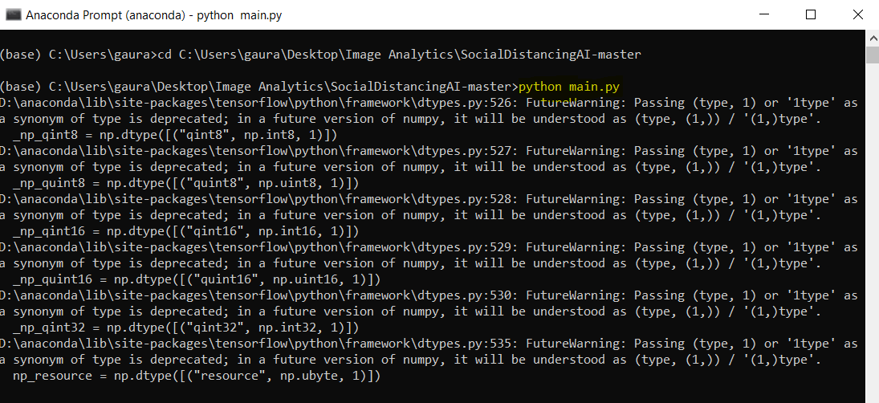

Once this function is executed, we will get one image frame

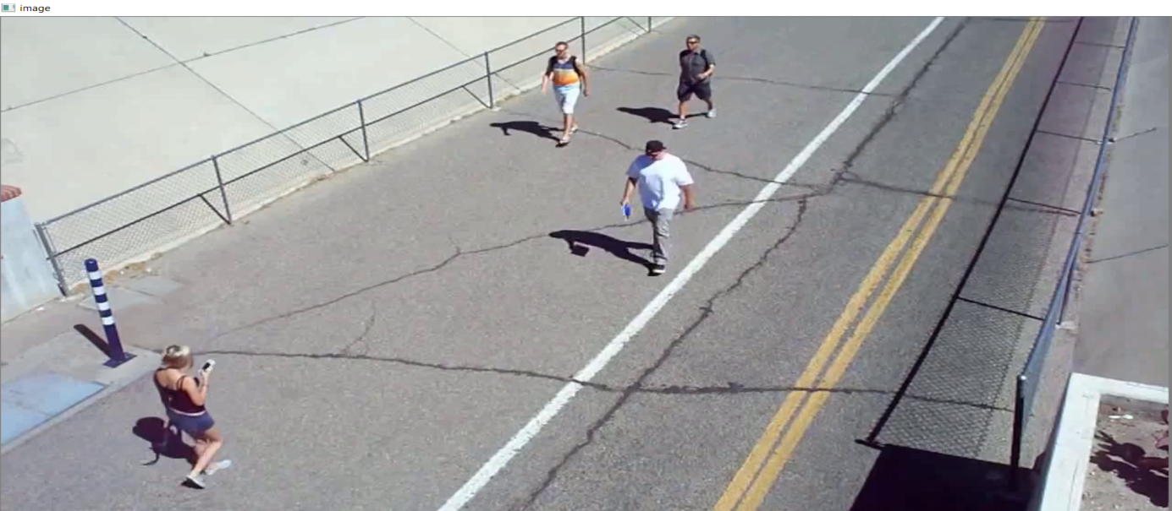

The code expects the user to mark 6 points by clicking appropriate positions on the frame.

These points are necessary to provide a user perspective of the video.

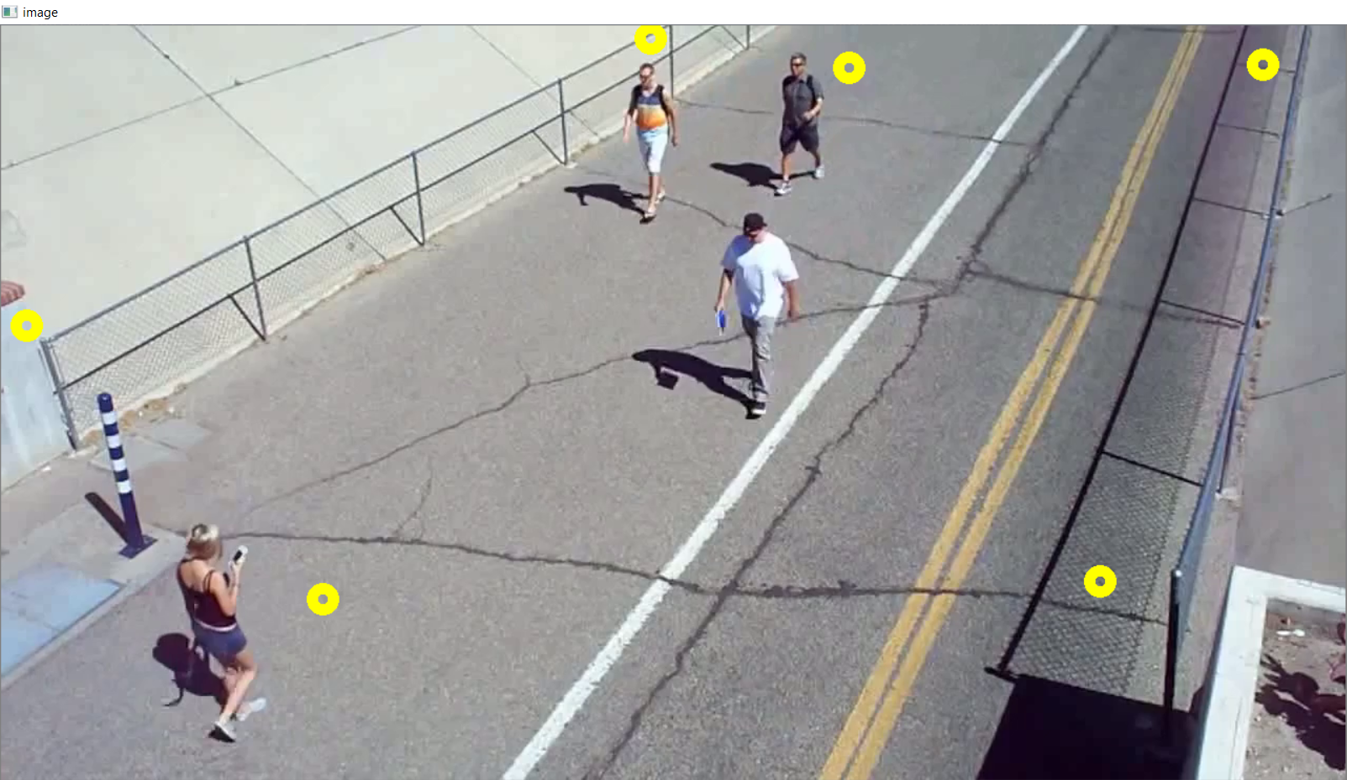

The first output of code is the original video with detected pedestrians in it. The pedestrians are localized with purple boxes. Please have a look to attached video .



Once the point detected we can also detect the data frame co-ordinate in the Anaconda prompt

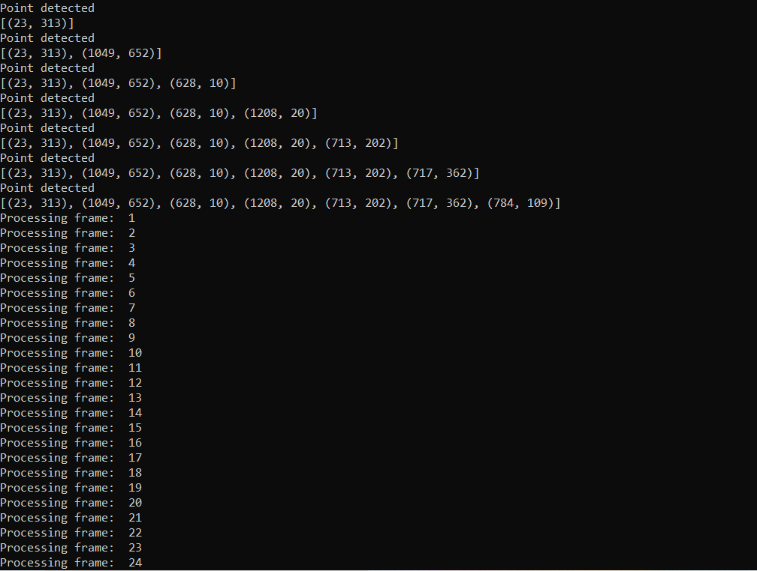

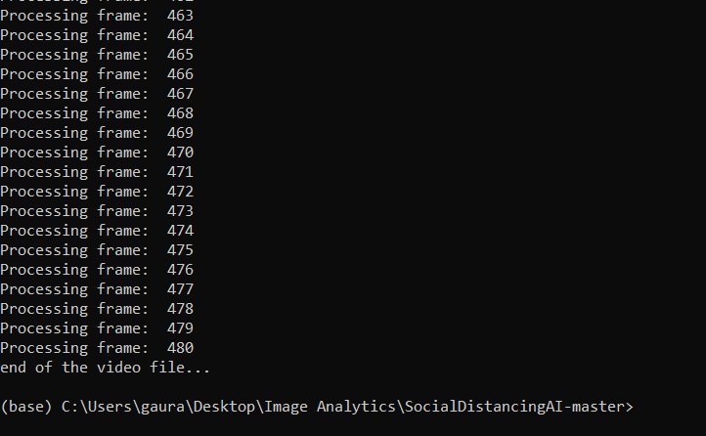

Social Distancing Parameters:

* #6 ft violations: Number of times the pedestrians violated the 6 feet safe distance threshold
* Stay-at-home Index: Quantifies how many people are staying home as compared to the normal routine pedestrian traffic. 0% means that there is no change in the pedestrian traffic compared to normal days, 50% means half of the people are staying at home.
* Social-distancing Index: Quantifies the social distancing being maintained. 50% means half of the interactions violate the safe 6 feet distance criteria.

**1.5 Working**

Localize the pedestrian in the frame

Detect the pedestrian in the frame

Get Cemara Frame

Display lines between pedestrian betweenwho are close

Calculate and Display Social Distancing Parameter

Find the Distance between pedestrian

**1.6 Summary**

The algorithm can be used to analyse social distancing in a public area and carry out necessary actions to better deal with the pandemic.

**MASK DETECTION**

For Mask Detection, we have used fast.ai for object detection.

* 1. We could have used Keras and TensorFlow, but it gave us a challenge of data augmentation. Implementing own data augmentation using Tensor Pack (a low level api) could have made it very complicated.
  2. We could have drawn the location of coordinates associated with each hand on a grayscale image and then perform data augmentation on both images and their corresponding masks. But the predictions could have become very chaotic.
  3. Using FastAi, we can debug all our code and coordinates augmentation is a part of the library core development.

The following shows the process how FastAi works:

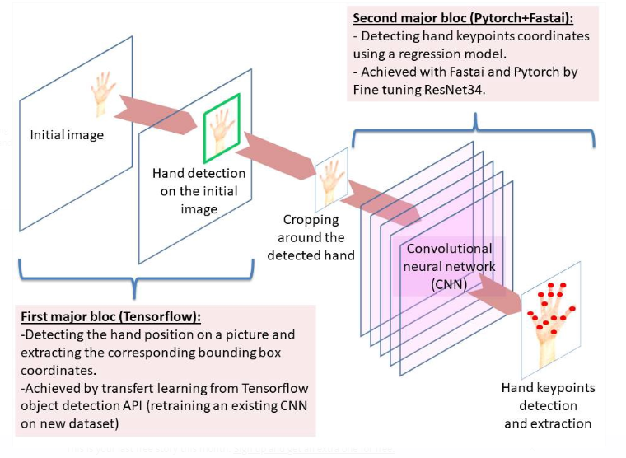

The following code was run on Google Collabs; however, one can also use Jupyter Notebook for running the same.

In Google Collabs, the runtime has been changed to GPU

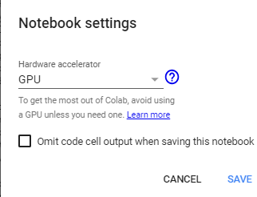

Installation of packages:

* FastAi

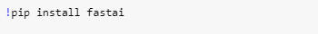

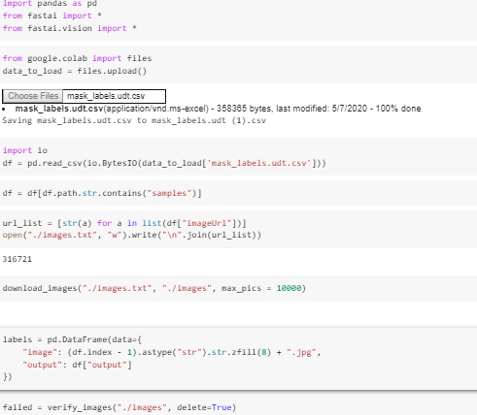

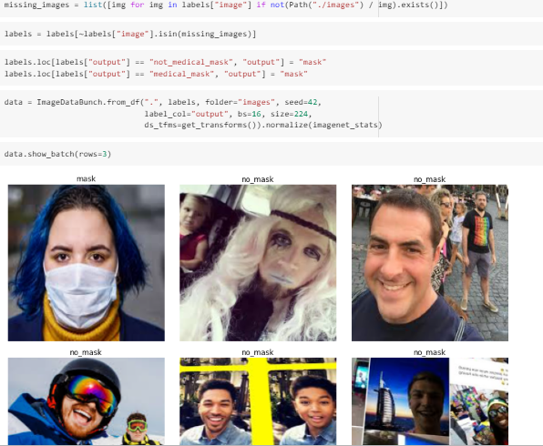

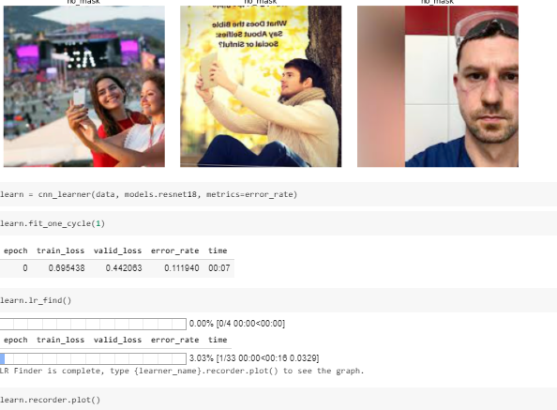

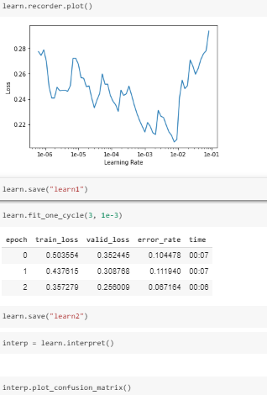

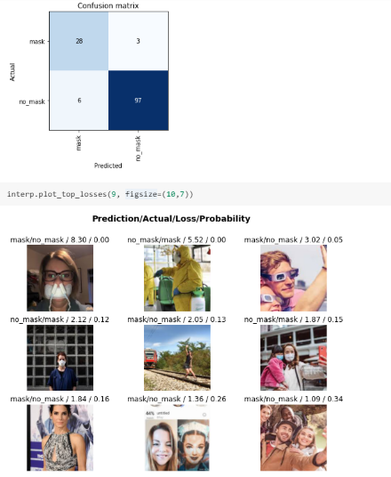

We have attached the python code for reference



**Detection of mask by developing the model in the pre-existing dataset**

**STEPS:**

1. **Importing required libraries.**

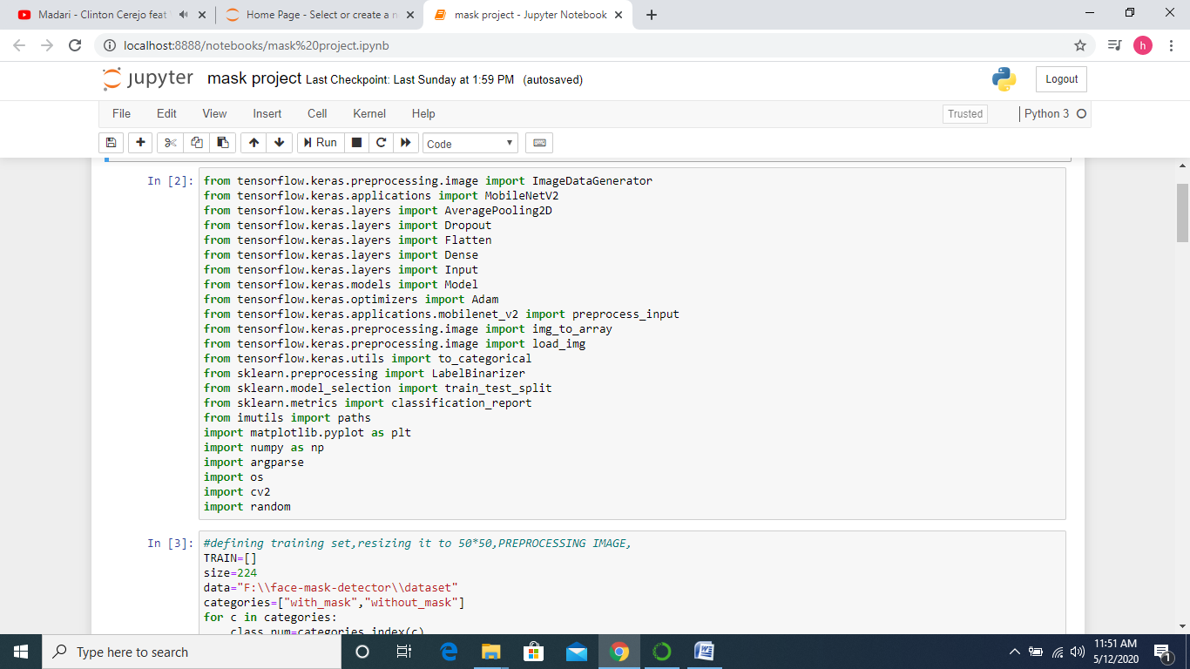

* TENSORFLOW- It allows developers to create large-scale neural networks with many layers.
* SKLEARN-Scikit-learn is a library in Python that provides many unsupervised and supervised learning algorithms. It also helps in evaluating the result of the model and splitting of training data.
* MATPLOTLIB-This library is particularly used to obtain graphical representation of metrics of the model.
* OS-The OS module in python provides functions for interacting with the operating system.
* CV2-OpenCV-Python is a library of Python bindings designed to solve computer vision problems.

**2- Getting the dataset from the disk to train the model.**

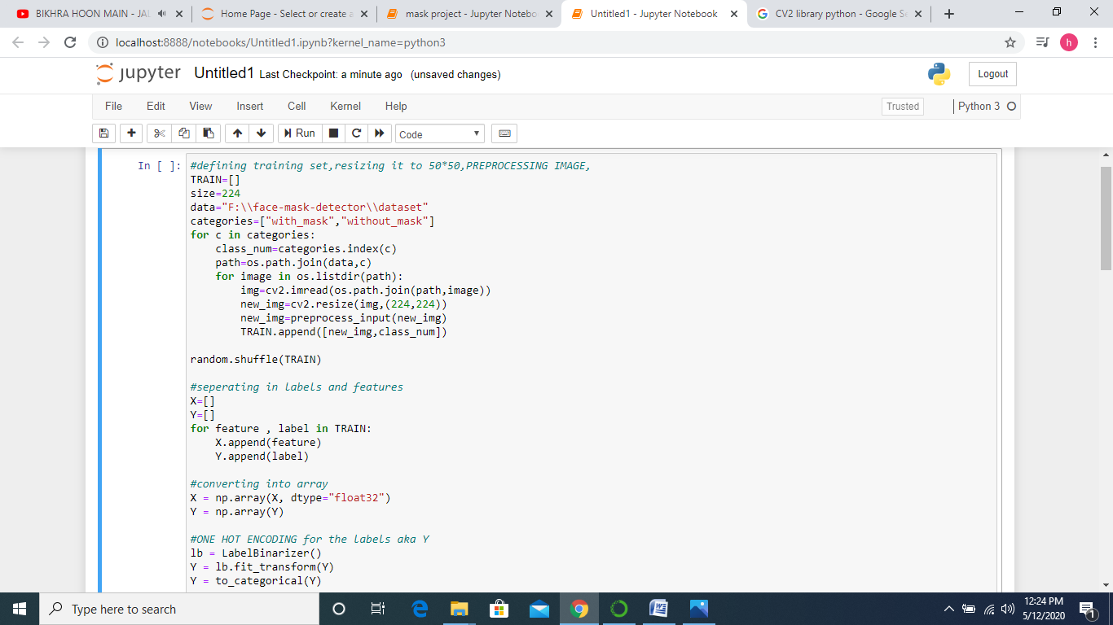

In the above code we have included the data set and also processed the data which is necessary before feeding it to the model. We have used the cv2 library to read the image and TensorFlow to pre-process the image.

Few examples of masked data.

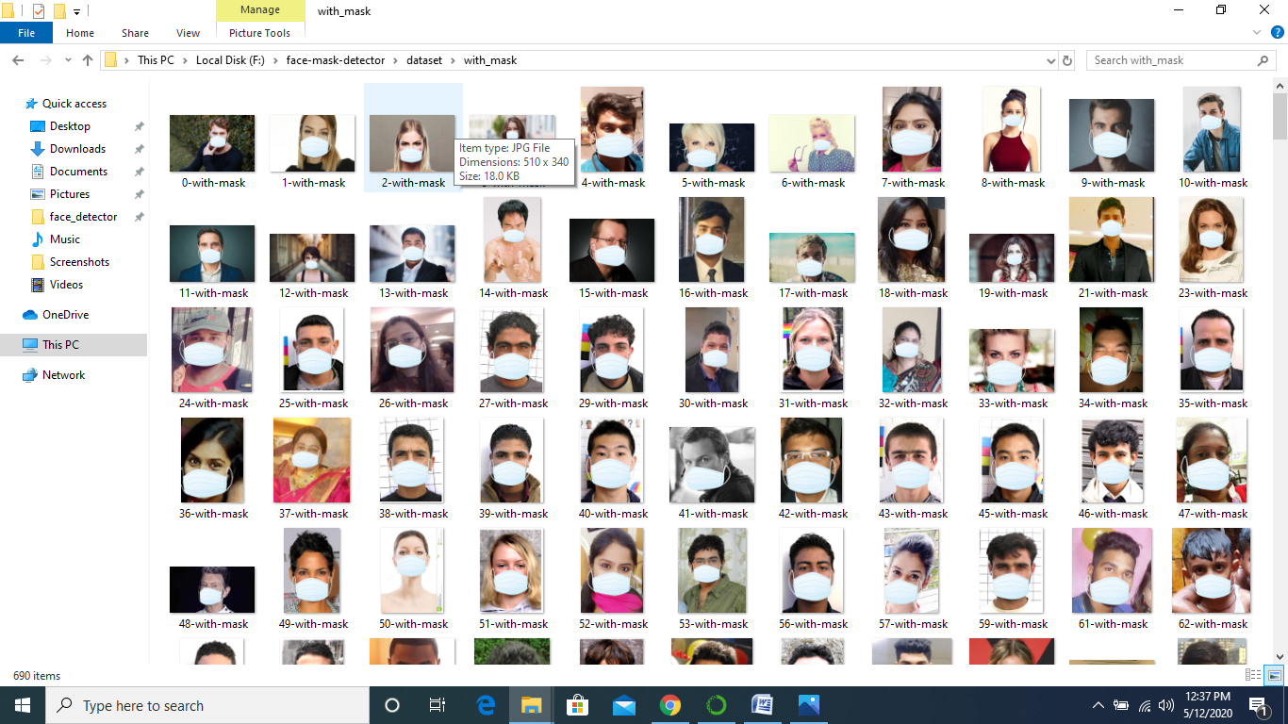

Few examples of unmasked data.

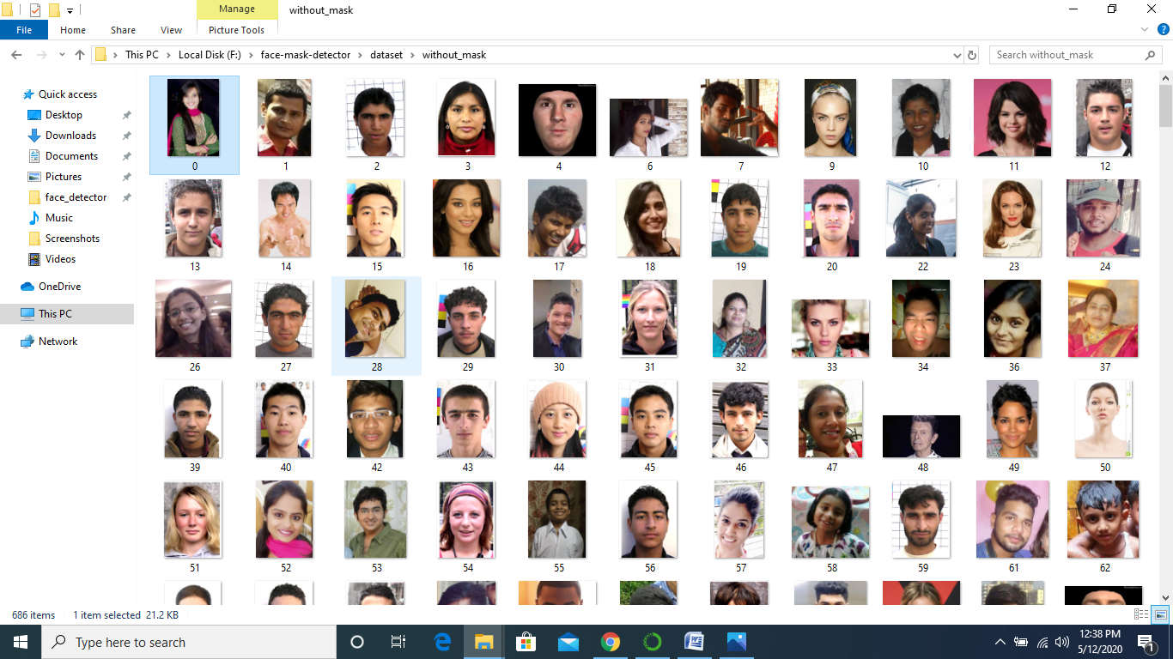

**3. Splitting of data into training and testing dataset and developing the neural network for facemask detection.**

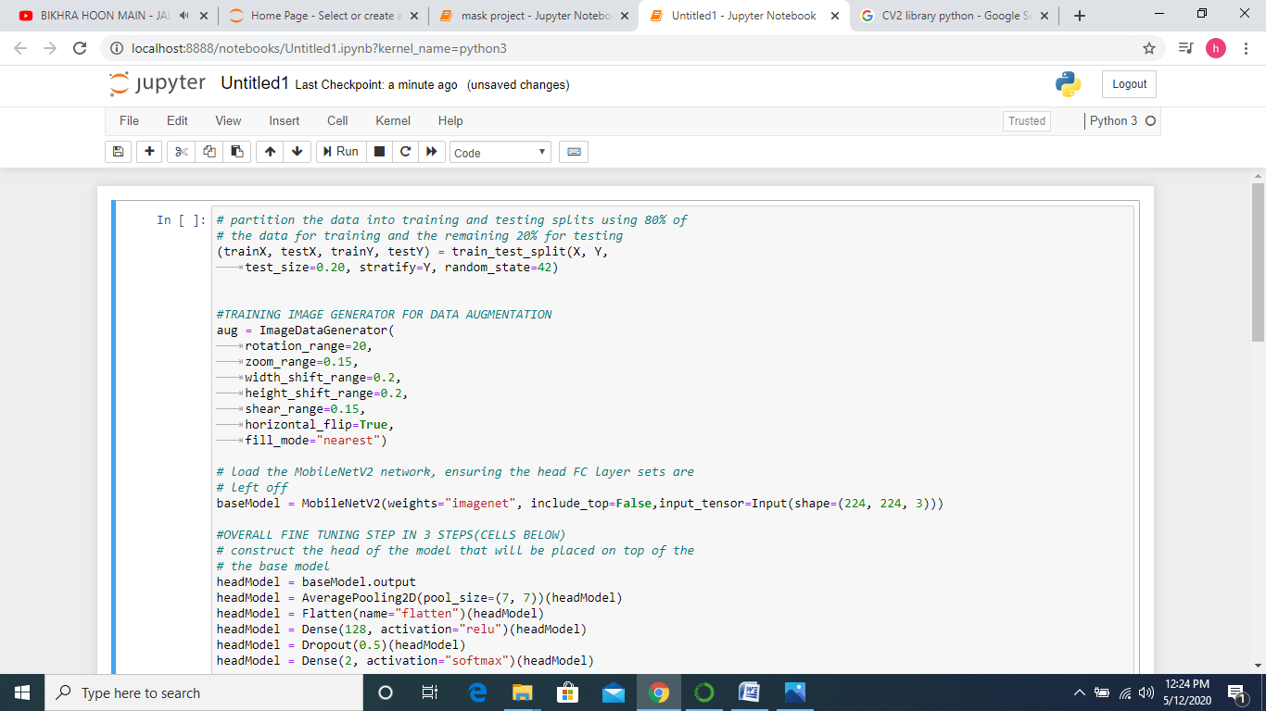

In this set of code, we first split the dataset into training and testing datasets.

As soon as the splitting is over, we generate copies of image with different zoom range, rotations , flips to feed these images in out model. After image augmentation we start building our neural network model. We use MobileNetv2 to develop out final fully connected layer. In the head model we develop out neural network using maxpooling, and convolution.

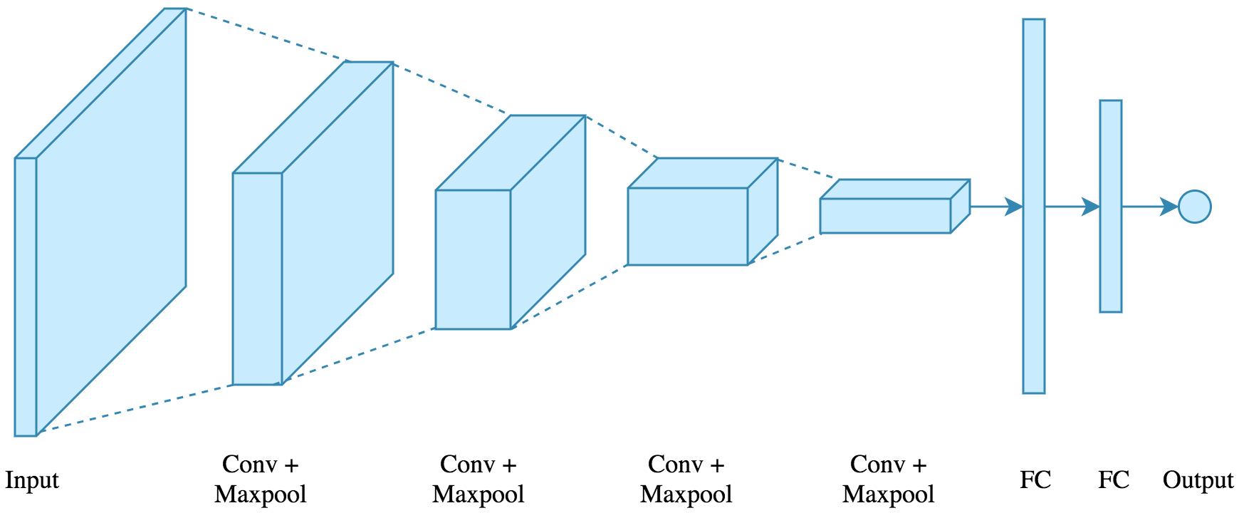

Effect of series of convolution and maxpooling on image.

**4. Compiling our model to train it over training dataset.**

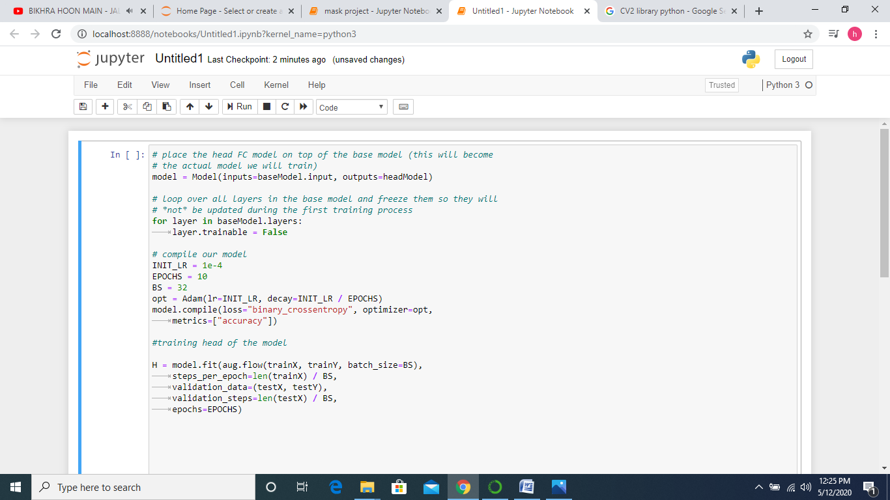

Now as we have developed our model, we will compile it. Here we will be compiling the model with epoch = 10, and with a batch size of 32.

After compiling the model ,we will train it over the training dataset. Here we are calculating loss in binary_crossentropy as it computes loss for every CNN output vector.

We will feed in the training dataset along with the outputs of that particular dataset to match the output given by the model.

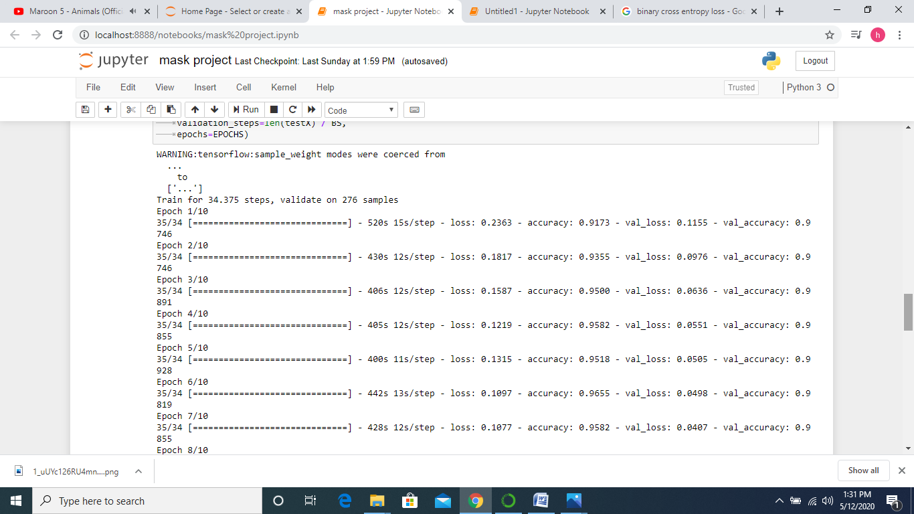

Every epoch result after fitting the model.

**5. Calculating the results of the model and displaying graphs to see the performance of the model.**

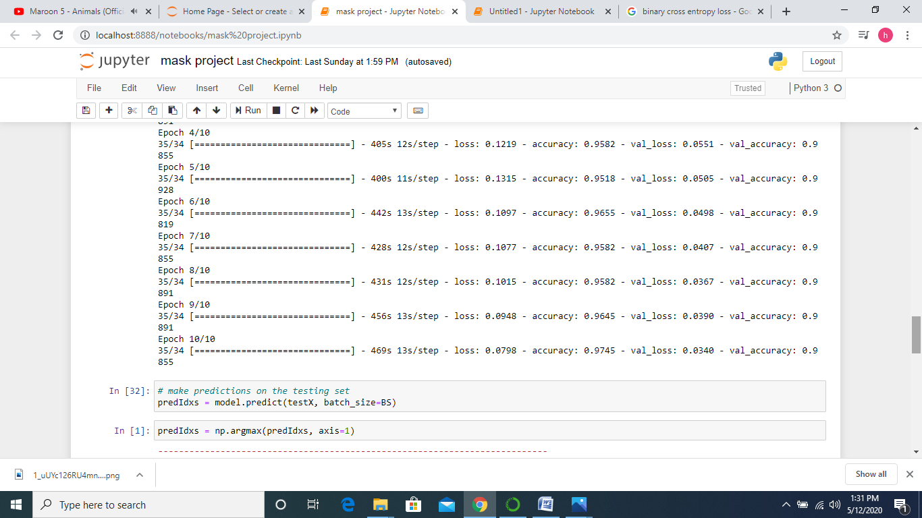

Here we are testing the model over the testing dataset and storing the probabilities. We use argmax function see which probability is maximum between mask and unmask label.

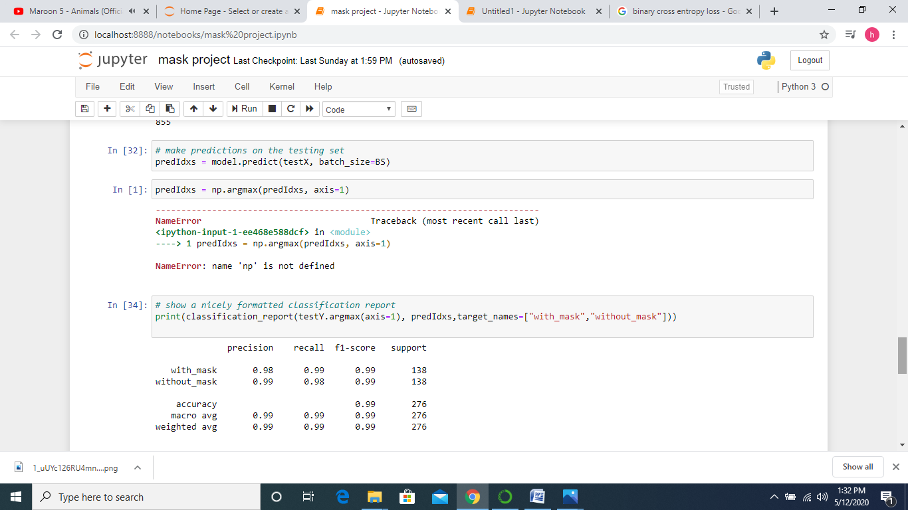

Accuracy and average results of the mask detector model .

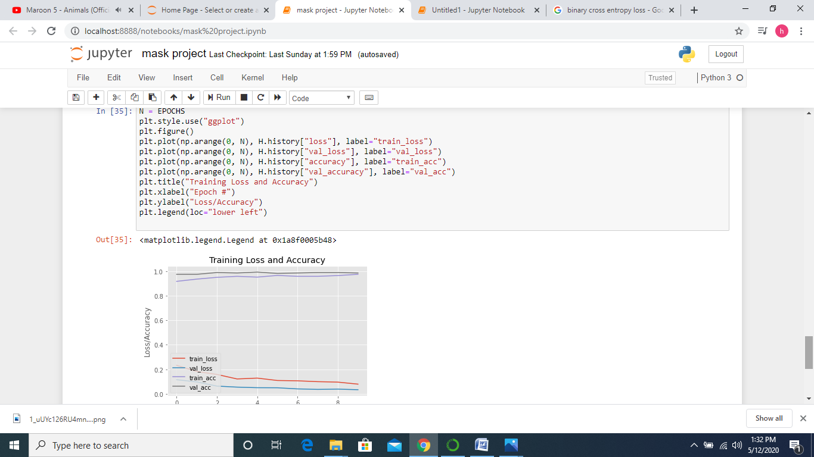

The graph presentation of the mask detector model describing the trend of train accuracy, train loss, Val loss, Val accuracy over the number of epochs.

**5. Defining a function to detect face from a frame and extract the ROI required to check for mask.**

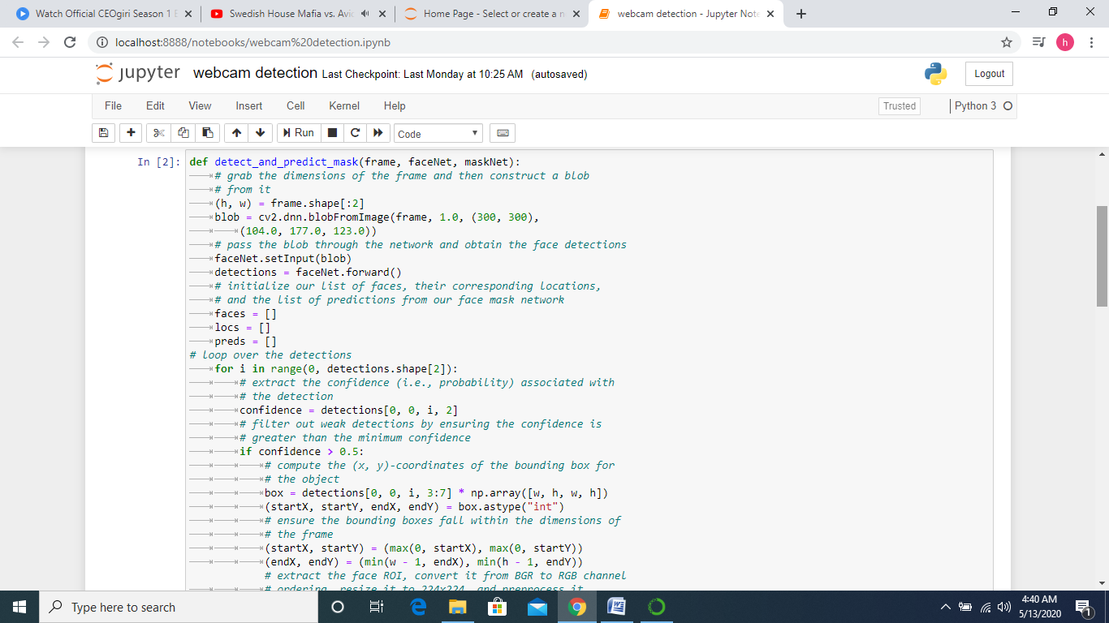

Here we are defining a function named **detect_and_predict_mask** in which we have passed three parameter which are **frame , face net , and mask net.** Frame parameter is the one which consists of a single frame taken from a ongoing video. Face net is a function which detects the face and ROI for the program from the frame. Mask net is the parameter which contains the model which we have made for mask detection.

In the function we are detecting the coordinates of the face from the frame and saving it for future use. Now after detecting faces we check whether the frame has a mask or not on it and then giving out

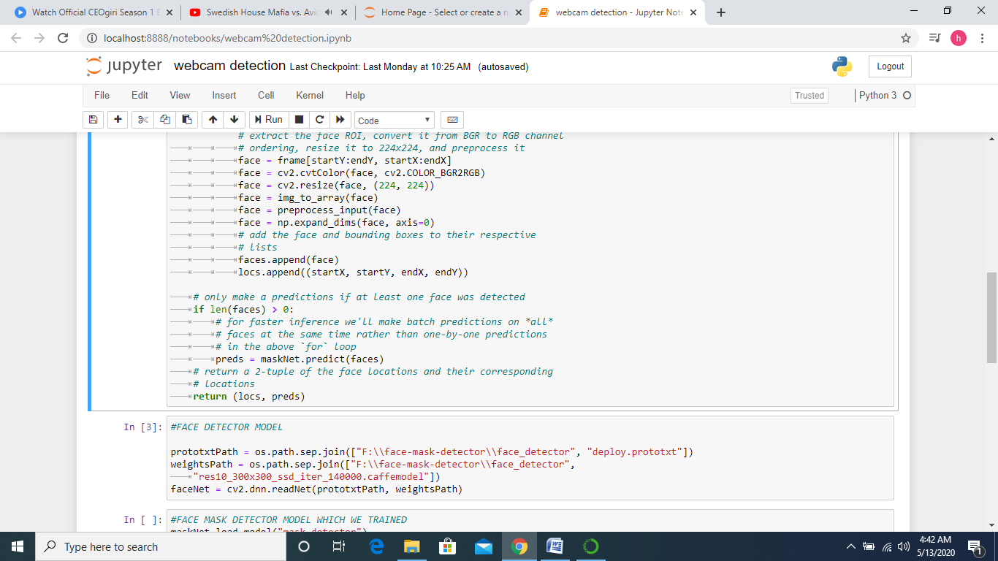

After getting the frame details ,it is pre-processed and fed to the mask net model for the checking of mask or non-mask.

**6. Calculating the probabilities of respective out and displaying it.**

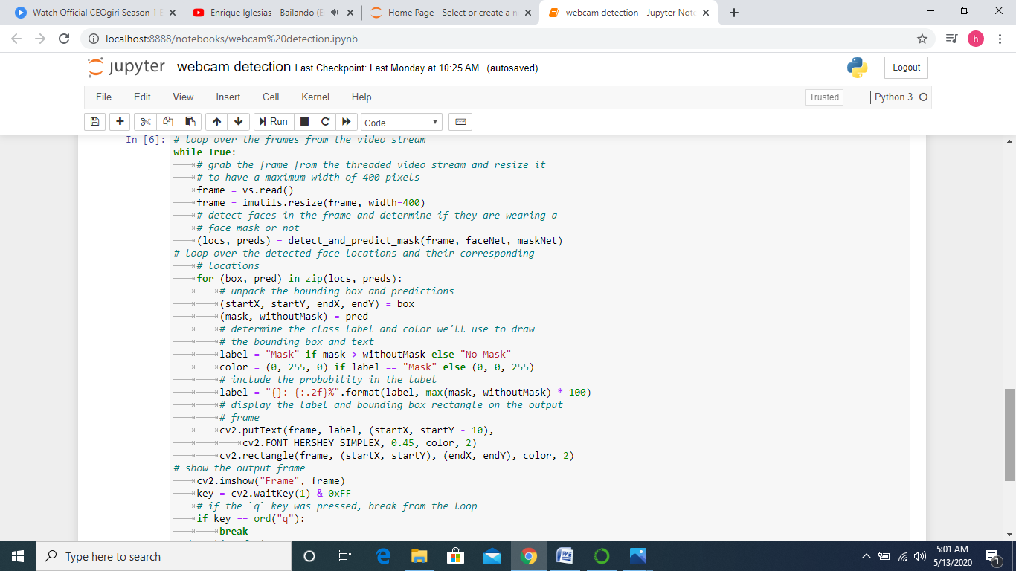

Now in this function we compare the probabilities we got for a particular frame and after comparing we enclose the face in the image with a rectangle of respective colour along with the proper output. Here we capture image through a webcam.

**Output**



If you observe the output you will find that the face without having mask is having red frame ,while once you will put the mask on face that red frame changes to green frame .

There are some fluctuations in the frame because during the test and trained there are some image data set where the orientation is different and due to that there is some fluctuations in the output video .

You can find the code for this module



**Conclusion**

The training at TATA STEEL proved to be a fruitful job for us. It has been a great experience to study the diverse aspects of an Industrial Enterprise. Right from knowing the disciplines and the policies of the company to the work and management which prevails in the company has been a great experience. Also, it was a knowledgeable approach to our entrance into the corporate world. . Unless one undergoes practical training, it is difficult to relate to all that is being taught in theory. Moreover, one gets the feel of working in a factory.

We have developed the code to detect the social distancing and mask on the face , we can use this project in the industry where people are working throughout in the motion for there respective work so we can detect there social distancing and mask on the face to avoid the transmission of the covid-19 .

**Bibliography**

1. Python library like

* <https://scikit-learn.org/stable/>
* <https://numpy.org/>
* <https://opencv.org/>
* <https://www.tensorflow.org/>
* <https://developer.nvidia.com/cuda-zone>

1. Articles from Medium and data science community

* <https://towardsdatascience.com/15-data-science-slack-communities-to-join-8fac301bd6ce>

1. stack overflow: for debugging the code .
2. Anaconda org

* <https://anaconda.org/>

1. Tableau public

* <https://public.tableau.com/profile/gaurav.kumar7925#!/>

**Compiled By:**

**Gaurav Kumar**

*Data Analytics & Decision Science*

*RWTH UNIVERSITY, AACHEN Germany*

**SHREYA JALAN**

*COMPUTER SCIENCE & ENGINEERING*

*VELLORE INSTITUTE OF TECHNOLOGY*

**Harsh Kaloya**

*ELETRONICS & COMMUNICATION*

*HERITAGE INSTITUTE OF TECHNOLOGY*

Please follow the link to get this whole module in git hub:

THANK YOU